Annex 3: Blood Sample Collection

A team of 23 non-medically trained staff were used to collect blood samples for dried blood spot (DBS) and 8 staff for PIMA CD4 testing under the BetterInfo Study. These samples were collected from ART patients mainly in the community and in a few instances at the health facility. Community collection of DBS is ideal to capture viral load results from HIV patients who are lost to follow-up (LFTU). Viral-load (VL) rapidly increases in People Living with HIV (PLWH) who discontinue antiretroviral therapy (ART) with accompanying risk of opportunistic infections and early death. Approaches to collect dry blood spots (DBS) in the community for VL testing from patients LFTU can enhance monitoring a group of patients at high risk of non-suppression. DBS was done on LTFU patients who had already started ART at the time they defaulted.

PIMA CD4 testing was done on LTFU pre-ART patients who were tracked in the community. Previous practices during study implementation indicate that as a priority, ART should be initiated in all adults with severe or advanced HIV clinical disease (WHO clinical stage 3 or 4) and adults with a CD4 count ≤500 cells/mm3. We collected blood from lost patient to understand what their CD4 count was during disengagement from care prior to ART initiation.

DBS

For DBS, the data collection team underwent a two-day short course which was conducted by medical staff (QA/QC Nurses) from within CIDRZ. The training component included the routine or standard procedure on how to safely collect blood from patients using a finger prick and ensuring that an adequate sample is dropped onto the DBS card (with at least 3 proper circles filled up) without any contamination. See figure 3.1 below:

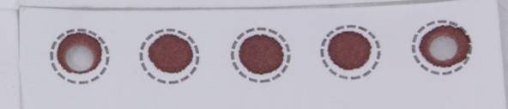
Figure 3.1: Blood has clotted

The training also included the component of how to label and dry the sample on a horizontal drying rack for at least 4 hours and on how to package and store the samples in readiness for sending/ delivery to the lab.

The training was done in two phases which comprised of a theoretical and practical session. The trainers begun by presenting on the importance and process of how to correctly collect DBS samples from adults using a finger prick. This session also included visual aids which helped to show the entire process starting from labeling all the way through to packaging with some pictures which showed bad or invalid samples which would be rejected by the lab. Figure 3.2.

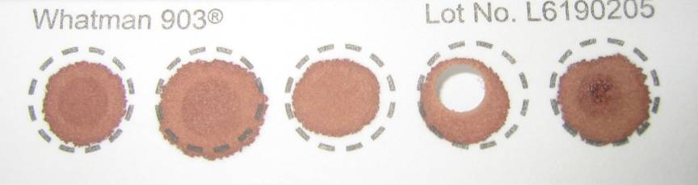
Figure 3.2: Specimen has clotted and appears layered

The second session entailed practicals where participants took turns practicing on how to collect samples from each other. These samples were then dried and packaged and quality checked to determine which ones would be rejected by the lab and thus helped the participants to better understand the process. This training was then concluded by having an evaluation exercise to help the trainers assess the levels of understanding for the individual participants.

During this training exercise, the trainers also took time to mentor the study leadership who would be monitoring collection of DBS by study staff. Field evaluations which were aimed at assessing staff performance during DBS collection were carried out during the study (See Appendix 1 for DBS evaluation form). This ensured quality control. In cases where errors were detected, staff were re-trained throughout the entire study period.

For samples which were collected in the community, we converted a basic 'First Aid box' into a field blood collection box with Styrofoam to separate phlebotomy supplies, sharps boxes (and other wastes for incineration at the facility) and a horizontal drying rack to help with transporting samples from the community to the facility for drying and packaging. The samples were dried for an additional 4 hours upon arrival at the facility. They were then packaged in labeled envelopes and couriered to the Central Laboratory using the laboratory courier system and study motorbikes.

NAME: JP 5040-133-0000-1
DATE: 14/11/2014
DOB: 01/10/2014
Facility: Kalingalinga -
District: Lusaka

Identifying information on the DBS card must match information on the lab requisition form. See figure 3.3.

At least 3 spots 6mm in diameter or larger must be obtained

After drying, DBS should be dark and uniformly coloured

All DBS must be collected on Lasec paper
Figure 3.3:

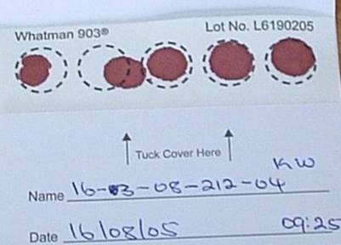
All 5 circles filled. At least 3 are valid. See figure 3.4.
Figure 3.4:

The challenges encountered during DBS collection are highlighted in Table 1.

Table 1: Challenges encountered during DBS collection
Challenges with DBS | Remedial/mitigation measures
Concealment of box: The box which was designed as a DBS kit was quite large and difficult to conceal in the community. | Use a smaller box or cover box in chitenge.
Poor sample collection for finger prick: Some patients did not have adequate blood samples from the finger pricks. | Invite patient to facility to collect sample with nurse.
Refusal to give blood: Some patients were refusing to give samples to study staff even after adequate explanations. | Patients were counseled on why the study was collecting blood.

PIMA CD4

For PIMA CD4, the training exercise was conducted by Alere, the manufacturer of the PIMA CD4 analyser used in the BetterInfo study (http://www.alere.com/en/home.html). Training on CD4 PIMA usage entailed a theoretical and practical component.

The theory component included an introduction which helped trainees understand the principles of CD4 and analyser operation as well as internal quality assurance for getting accurate results and minimizing errors starting from charging and running controls each day through to cleaning and storing the machine after use. This was followed by basic troubleshooting procedures which could be carried out by end users as well as the PIMA Error Codes which needed to be understood by all end users. The final component of the theoretical presentation was on how to pack and store the PIMA machine in readiness for transportation from one location to another. This was an important component considering that most of the testing was to be done in the community.

The second component of the training was practical and included having participants practice using the actual PIMA machine and taking turns pricking, collecting and running tests on each other. The training was concluded by the trainers carrying out an evaluation exercise to ascertain the levels of understanding for the individual participants. Just like in the case of the DBS, the study leadership team was equally trained to carry out routine monitoring, quality control and retraining to help with ensuring smooth flow of PIMA CD4 testing activities for the entire study period. A total of 13 staffs were trained in PIMA CD4 testing under the study.

During the course of the study, field staff ran tests on patients and transmitted results to the central server by connecting to the CIDRZ wireless network using the PIMA machine. These results were then downloaded and quality-checked by trained staff at CIDRZ HQ and feedback was provided to the field staff to help with quality improvements.

Table 2: Challenges with PIMA CD4
Challenges with PIMA CD4 | Remedial/mitigation measures
Errors on PIMA machine in field: Some PIMA machines kept on giving errors in the field and turnaround time from the supplier to fix the problems was not very good. | - Staff refresher trainings were conducted and this was followed with observation of how staff operated the machines.  - We embarked on weekly meetings with supplier.
Difficult to bleed patients: Some patients did not have adequate blood samples from the finger prick to run a CD4 test hence resulting in errors (the study had already come to an end by the time the whole blood component was approved in the protocol).p | - Patients were referred to facility.
Sampling errors by analyser: The machine gave errors when testing patient’s samples. | - Test was repeated and if the error was still there, the manufacturer was informed.

Appendix 1: DBS Field Evaluation Questionnaire

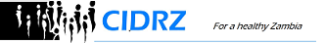

Better Information for Health in Zambia (BetterInfo) Study

DBS Field Evaluation Questionnaire

- Did tracker engage patient in what was happening?
Yes No

- Did tracker ensure patient’s hands were warmed up?
Yes No

- Were gloves worn before touching anything to be used in DBS collection?
Yes No

- Were all DBS collection supplies removed and prepared before starting procedure? (Tick all that applies)
DBS Supplies | Tick (√)
Cotton wool
Plaster
Lancet
DBS card
Sharps boxes
Alcohol swab

- Did tracker fill in patients details on both DBS card and requisition form before collection? (Tick all that applies)

REQUISITION FORM | Tick (√) | DBS CARD | Tick (√)
Collection date and time |  | Collection date and time
PID |  | PID
Sex |  | Sex
Study/visit |  | Clinic/Facility name
Sample storage
Clinic/Facility name

- Was the patient’s finger cleaned with an alcohol swab in one direction?
Yes No

- Did tracker ensure that the patients hand was below the heart during DBS collection?
Yes No

- Was lancet properly positioned? (i.e. not too close to the tip or side of the finger).
Yes No

- Was lancet disposed in sharps boxes?
Yes No

- Was puncture done correctly?
Yes No

- Was patient’s finger messaged properly?
Yes No

- Was the collected DBS valid?
Yes No

- Were details filled in correctly on the requisition forms?
Yes No

- Was the collected DBS packaged properly?
Yes No

